Example Survey Questions for Experience Design Evaluations

This informational document contains a list of survey questions commonly used to explore various aspects of an experience design. When it comes to the most crucial design aspects, best practice is to ask multiple versions of the same question. This way if one of the versions of the questions is interpreted different than you expected, you still have useful data from the other questions.

All questions (unless otherwise noted) are followed by scales in which participants are asked to rate their agreement or judgement.
Disagree Neutral Agree
Example: Strongly Disagree 1 2 3 4 5 6 7 Strongly Agree

Questions about the Task (asked before and/or after the task)

Perceived Task Performance
I was effective at performing [the task]?
My experience performing [the task] was realistic.
I think I was successful at completing [the task]?
It was important to me to be successful at [the task].

Perceived Cognitive Load
How hard was it mentally to [complete the task]?
Difficult
Challenging
Easy
Simple

Enjoyment
I found [the task] enjoyable.
I had fun [performing the task].
The experience was boring.
The [task] really annoyed me.
The experience left me unsatisfied.

Task Immersion
During the exercise, I was able to block out most other distractions.
During the exercise, I was absorbed in what I was doing.
During the exercise, I was immersed in the game.
I was distracted by other attentions very easily.
My attention was not diverted very easily.

Temporal Dissociation (losing track of time)
Time appeared to go by very quickly.
During the exercise, I lost track of time.
Time “flew” when I was [performing the task].

Curiosity
This experience excited my curiosity.
This experience made me curious.
This experience aroused my imagination.

Perceived Attention
During [the task], the computer screen displayed some items that may have caught your attention more than others. Estimate how much of your attention each item captured. (1=No Attention, 7=Full attention)

Task Comfort
The [task] was very uncomfortable.
I was relaxed during [the task].
I was tense during [the task].

Behavioral Control
I tried hard to appear truthful [or some other trait] during [the task].
I tried hard to avoid appearing suspicious [or something else].
I did not worry that I might be viewed as suspicious [or something else].

Task Stress
During the [task], I felt…
Nervous
Flustered
Tense
Relaxed
Uneasy
Stressed

Excitement
[The task] was exciting.
It was a thrill to [perform the task].

Perceived Task Cognitive Ease
[The task] seemed automatic.
I [perform the task] without thinking how to [perform the task].

Perceived Understanding
I have an understanding of [the task topic].
I have an understanding of [the task].

Perceived Anthropomorphism (human-like qualities in a system interaction)
There is a sense of human contact [in the task/prototype].
There is a sense of personalness [in the task/prototype].
There is a sense of sociability [in the task/prototype].
There is a sense of human warmth [in the task/prototype].
There is a sense of human sensitivity [in the task/prototype].

Perceived Social Presence
I can sense the existence of other people who are [performing the task/using the prototype].
I can sense the existence of other people who share information about the [task/prototype].
I can sense the existence of other people who have [used the prototype/performed the task].
I can sense the existence of other people in this [task/prototype].

Perceived Ease of Use
[Performing the task] was easy.
I found it easy to [accomplish the task].
My interactions with [the solution] were clear and understandable.
It would be easy for me to become skilled at using [the system/solution].

Perceived Usefulness
Using [system/solution] would enable me to accomplish [task type] more quickly.
Using [system/solution] would improve my [task type] performance.
Using [system/solution] would improve my [task type] productivity.
Using [system/solution] would improve my [task type] effectiveness.
Using [system/solution] would be useful for [conducting task type].

Intention to Use
Please mentally compare [system/app] to similar solutions you might think of, or to not using any solution at all. Please indicate how much you agree or disagree with the following statements:
If I had access to a fully-functional [system/app name], I would intend to use it.
Assuming I had a full-featured version of [system/app name], I predict I would use it.

System Feedback Effectiveness
I feel confident that feedback mechanisms give accurate information.
A considerable amount of useful feedback information was available.
I believe that the feedback mechanisms in [the prototype] are reliable and dependable.

Perceived Transaction Trustworthiness
The services in [the prototype] guarantees that I will get what I pay for.
The services in [the prototype] protects me.
The services in [the prototype] guarantees [an outcome] will occur easily.
The services in [the prototype] make me feel secure about my online purchases.

Perceived IS Security
The information security mechanisms in [the prototype] make me feel secure about providing sensitive information.
The information security mechanisms in [the prototype] are effective in protecting my information.
The information security mechanisms make me feel totally safe about my sensitive information.
Overall, the [prototype] is a safe place for sensitive information.

Task Realism
How realistic was [the task]?

Confidence (paired with any other question)
How confident are you in that assessment?

Perceived Effort
During [the task], how important was it to you to succeed?
How important was it to you to accomplish the task?

System Usability Scale (considered a “quick and dirty” measurement of basic system usability. Often uses a 0-3 scale)
1. I think that I would like to use this system frequently.
2. I found the system unnecessarily complex.
3. I thought the system was easy to use.
4. I think that I would need the support of a technical person to be able to use this system.
5. I found the various functions in this system were well integrated.
6. I thought there was too much inconsistency in this system.
7. I would imagine that most people would learn to use this system very quickly.
8. I found the system very cumbersome to use.
9. I felt very confident using the system.
10. I needed to learn a lot of things before I could get going with this system.
Note: To calculate an overall usability score:
1. Reverse-score responses to all even-numbered questions (this makes all higher numbers mean “better”)
2. Multiply all scores by 2.5 (this changes possible score range from 0-40 to 0-100)
3. Calculate each individual’s overall score and average all individual scores together.
Each question can also be analyzed separately to identify best and worst usability aspects.

Net Promoter Score
How likely is it that you would recommend [the experience or system] to a friend or colleague? (typically uses a 0-10 scale)

Example Open-ended questions:
Transcribed by interviewer:
What do you expect to see here?
Why do you think that?
What would you do next?
How would you start [accomplishing the task]?
Survey only:
What other comments or feedback do you have for the research team?
What is your understanding of the purpose for this evaluation today?
Why do you think someone would [perform the task]?
What do you think should happen when a person [performs the task]?
Tell me why you might not want to do [this task].
Once [the task] is complete, what do you think the results will be?

Questions about Respondent Traits (for matching to or identifying personas):

Fanaticism
I consider myself to be a [task topic] fan.
My friends see me as a [task topic] fan.
I believe that following [task topic] is the most enjoyable form of entertainment.
My life would be less enjoyable if I were not to follow [task topic].
Being a [task topic] fan is very important fan to me.

Professional Experience
I have professional experience involving [the task].

Computer Self-Efficacy
I am able to keep up with important technological advances in computers.
Computers make me feel uncomfortable.
I get a sinking feeling when I think of trying to use a computer.
Computers scare me.
I look forward to using a computer.

Computer Playfulness
The challenge of learning about computers is exciting.
If given the opportunity, I would like to learn more about computers.
When interacting with computers, I consider myself…
Spontaneous
unimaginative
flexible
creative
playful
unoriginal
uninventive
If I heard about a new information technology, I would look for ways to experiment with it.
In general, I am hesitant to try out new information technologies.
Among my peers, I am usually the first to try out new information technologies.
I like to experiment with new information technologies.

Perceived Ability
I am good at [task type X].
I have an aptitude for [task type X].
I typically perform very well at [task type X].

Emotional State
Right now, at this moment, I feel…
Interested
Scared
Upset
Enthusiastic
Excited
Guilty
In control
Angry
Proud
Hostile
Nervous
Strong

Horizontal Individualism (or Need for Uniqueness)
I often do "my own thing"
I am a unique individual
I enjoy being unique and different from others in many ways
My personal identity, independent from others, is very important to me

Vertical Individualism (or Competitiveness)
It annoys me when other people perform better than I do
Competition is the law of nature
When another person does better than I do, I get tense
It is important that I do my job better than others

Horizontal Collectivism
The well-being of my co-workers is important to me
If a relative were in financial difficulty, I would help within my means
It is important to maintain harmony within my group

Vertical Collectivism
I would sacrifice an activity that I enjoy very much if my family did not approve of it
I would do what would please my family, even if I detested that activity
I usually sacrifice my self-interest for the benefit of the group
Children should be taught to place duty before pleasure

Independence
I take responsibility for my own actions
It is important for me to act as an independent person
I should decide my future on my own

Interdependence
I will sacrifice my self-interest for the benefit of my group
I maintain harmony in the groups of which I am a member
I respect the majority's wishes in groups of which I am a member
It is important to consult close friends and get their ideas before making a decision

Personal Image Importance
It is important for me to look good in front of other people
Maintaining a positive image is important to me
Making a good impression is important to me
I prefer to be direct and forthright when discussing with people

Personal Privacy Importance
I want my privacy respected
I have clear boundaries for other people
I prefer to keep people as a distance

Others’ Image Importance
I feel bad for people who embarrass themselves in public
It is important for me to not make my conversation partner look bad
When in public, I hold back my criticism of others so that they will not look bad

Others’ Privacy Importance
I try to avoid telling other people what they should do
It is important to respect other people's boundaries
I try not to invade other people's personal matters

Emotional Control
It is difficult for others to know when I am sad or depressed.
My facial expression is generally neutral.
I rarely show my anger.
People can always "read" my feelings even when I'm trying to hide them.
I am able to conceal my true feelings from just about anyone.

Social Control
I am usually very good at leading group discussions.
When in groups of people, I have trouble thinking of the right things to talk about.
I am not very good at mixing at parties.
I am often chosen to be the leader of a group.

Big 5 Personality Factors
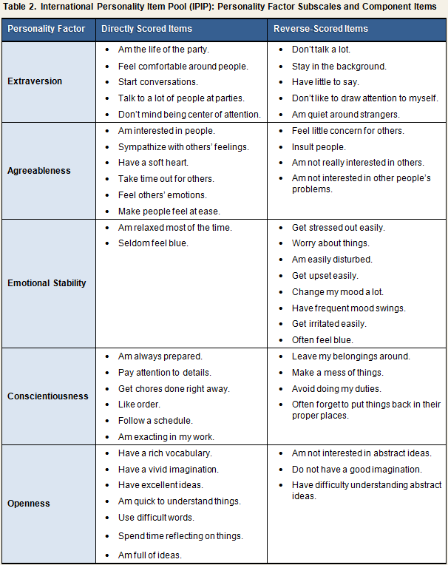

Yes/No questions:
Besides hearing that this experiment will involve testing new technologies, have you heard any details of this study prior to your participation?
Were you using the [new prototype/old system]?
Were you instructed to [perform the task]?
Is this your first time evaluating this system?
It is very important that details of this research experiment are not shared with others. Many of your friends or associates may also participate, and knowing details beforehand would corrupt the study and ruin the research. Please do not discuss ANY details of the study with anyone until the research program is complete. Will you refrain from discussing ANY details of the experiment until the research program is complete?

Demographics:
What is your age?
What is your primary race?
What is your gender?
Is English your first language?
What is your highest level of education completed?

